ABOUT THE CLUB
Outboard motors have been manufactured for over 100 years. Therefore, it is no surprise that a number of people should become interested in collecting antique outboards. The interest became so widespread that by 1960, antique outboard collectors began to correspond with one another.
In October 1965, five collectors planned and organized "The Antique Outboard Motor Club". In January of 1966, the first issue of "The Antique Outboarder" was printed. Thirty copies were mailed to members. By October of 1966, membership had increased to more than 200 people in several countries. Our growth continues with membership now in the area of 3,000 dedicated members from (currently) 14 countries.
A number of antique outboarders are"old-timers" who are motor and boating enthusiasts of long standing, or who have been involved in the manufacture of outboards. Other members just collect old outboards - a few members owning several hundred! Collecting is fun and exciting; some of these outboards are 5-cylinder, radial engine, tractor lower units, underwater engine, air drive units and folding motors - all typical forerunners of modern outboards.

Insert Local Chapter information here

Sign up online or write to:
AOMCI Membership Services
PO Box 251
Vinton, VA 24179
www.aomci.org
memberservices@aomci.org
Introductory membership
$40.00
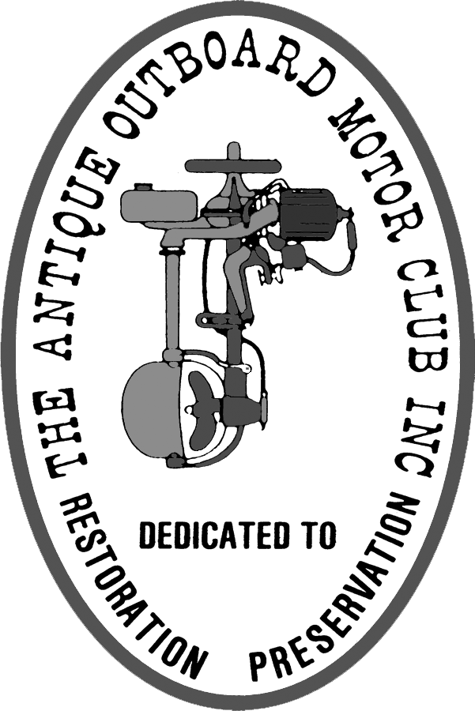
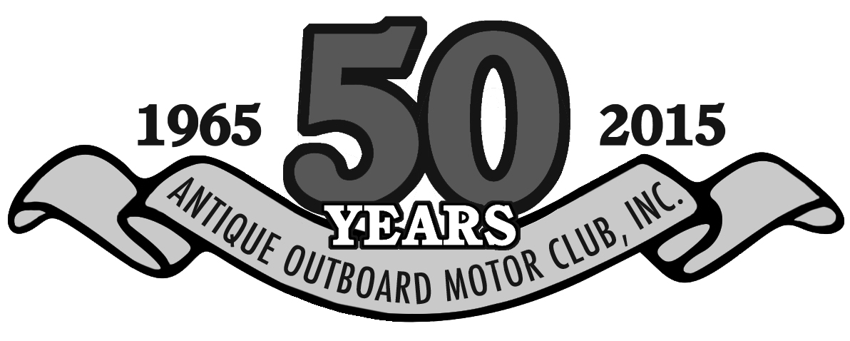
In 1866, the first outboard device was patented. While over 160 manufacturers have entered the industry since that time, few remain. Names like Caille, Waterman, Walnut, Lockwood, Motorgo, Columbian, Gray and Ferro are all but forgotten except within the AOMCI.
The AOMCI is a world-wide, non-profit organization devoted to people who are interested in antique outboards, their preservation and their restoration.
GET A KICK OUT OF AN OLD KICKER?
You're not the only one who's interested in old outboard motors. There are lots of people - businessmen, doctors, bricklayers, dentists, mechanics and people of all ages have the opportunity of sharing the rewarding experiences offered by the non-profit Antique Outboard Motor Club, Inc. (AOMCI).
PUT SOME GAS IN YOUR HOBBY!
Your membership in AOMCI will provide you with a rich mixture of personal associations and accomplishments. You'll meet interesting new people while following leads provided by the Club to add motors to your collection; make new friends by joining a chapter of the Club in your area or by corresponding with other members and realize a great deal of satisfaction and pride from participating in displays, shows and Club Meets.
TIE A ROPE AROUND IT!
Get started by advancing your spark of interest and join AOMCI. You'll get a new and broader perspective or what fun and enjoyment a well-rounded hobby can bring. Antique outboarding offers a more personal and meaningful thrill than that found in modern boating.
MAKE IT GO!
You'll be able to take a battered and worn, grease covered old engine and enjoy the fun and satisfaction one gets from putting life into an old motor and letting it "show its stuff" to those curious watchers on the shore.
Suddenly those hard to find motors, parts, owner's manuals and instruction books are available to you through the Club resources. Antique engine parts are still to be found - if you know where to find them.
YOU WILL BE OFF AND RUNNING!
As a member of AOMCI you will receive a membership card, use of the extensive Club library, the most recent copy of the Club magazine.
You can participate in both indoor and outdoor Club Meets run engines and talk shop with friends having the same interests as yours. High points of the Club's activities are the annual water rallies held at different times in several locations in Canada, the United States and beyond. These "meets" give members a chance to show off their motors, swap parts, exchange information and learn more about antique outboarding. Prizes are offered for, among others, "The Fastest Motor of its Class", the "Oldest Motor" and "The Best Restored". Spectator interest is terrific.
In most parts of Canada and the USA, members live close enough to one another so that regular local chapter meetings are held during which - you guessed it - they can discuss and "play with" old outboards.
You can talk with or correspond with others having the same kind of engines or the same favorite topics you do by belonging to one of the many "Special Interest Groups" offered by the Club. Different engine makes, history, racing, unusual motors are just a few of the unique groups you might wish to be part of.
CLUB PUBLICATIONS
You will get full bore coverage on all outboarding subjects in the quarterly Club magazine The Antique Outboarder, a high quality quarterly publication with lots of photos and color content and filled with historical and technical articles, including many useful tips to get and keep your old iron running, along with Club and Chapter news and classified ads. Members also enjoy exclusive access to members-only content on our website, www.aomci.org including discussion boards and the extensive "Old Iron Reference Library."
LOCAL CHAPTERS
The AOMCI has over 40 local Chapters across the United States and Canada that you can join once you are a member. Chapters organize swap meets, displays and "wet meets" where you can go and get help to get your old iron running or just enjoy a good old fashioned time in a family friendly environment. If there are no local chapters in your area you only need to recruit two other friends to start one!
Insert Local Chapter Information here!
visit www.aomci.org for a listing of all the Local Chapters.
It's up to you to pull that first starter rope and join The Antique Outboard Motor Club. Don’t miss another day of fun and enjoyment!

