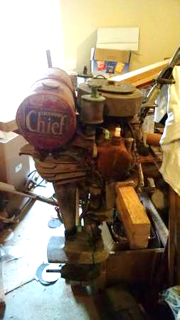

Found this the other day. After driving 4 hrs in a steady down pour to look at it I was sure to buy it. Seems to be in pretty good shape….on the outside anyway. From what I gather it’s a 1929 Lockwood racing chief. It’s not supposed to be one of their better racers and made just a single year. Peter Hunn’s book shows one with the twin carbs removed after its racing career was over and a single carb added for ease of operation. That’s the way this one is. I thought I saw an old picture of one with a single carb. Maybe they let a few out of the factory that way? I thought I was pretty good at scowering the internet for info but I really can’t find much on this model or any other Lockwood’s for that matter. So if anyone can send me any info this way I would sure appreciate it! Glen

