Rediscovering the Wheel part 1[Jim Purcell]
As the cold weather descended on the East Coast it became time to work on my indoor projects. First up was the restoration of the steering wheel off my 1949 FC Vagabond. The wheel was made by the Sheller Manufacturing Company, which began in 1916 as a wood rim steering wheel manufacturer in Portland, Indiana. In 1958, Sheller produced the first recessed safety steering wheel and padded dash safety package offered by Ford Motor Company. The wheel was on the boat when I purchased it three years ago. The 1949 edition of the FeatherCraft catalog lists the steering wheel assembly, complete with pulleys and cable for $17.50. It seems likely the owner could select from a variety of wheels available at the time.

The first step was to remove the wheel. This should have been an easy task, however after decades of corrosion, such was not the case. With the help of George Cornog, a member of the Knuckle Buster Chapter, I was able to remove the center cover and unscrew the nut holding the wheel to the steering shaft. No amount of prying, heating, or banging could remove the wheel. We tried wheel pullers and lubricant, to no avail. I was able to remove the pulley assemble from the shaft and remove the wheel and the shaft. I thought that was about the best I could expect. I was wrong. Shortly thereafter I had an opportunity to visit Bob Grubb. Those of you who know Bob know there are few problems he is unwilling to attack, and attack he did. He studied the situation for a moment, took the wheel and shaft, installed it in this medieval looking press in his garage, and with the use of a breaker bar, separated the wheel from the shaft in no time. With that less than simple task completed, it was time to get to work on the wheel.

The first step was to remove the old paint, dirt and grease. This is a messy job. It is best to wear a full-length shop jacket, hat, eye protection, and respirator. I used an oscillating sanding tool from Harbor Freight, with 60 grit sandpaper. Mineral spirits was used to clean the surface. The next step was to grind out the cracks. For this step, I used a rotary tool, a tungsten carbide bit, and patience. I ground each crack down to the metal bar that forms the frame. A brass wire brush worked well to clean out the cracks.

[Original condition] [After sanding and cutting out the cracks]
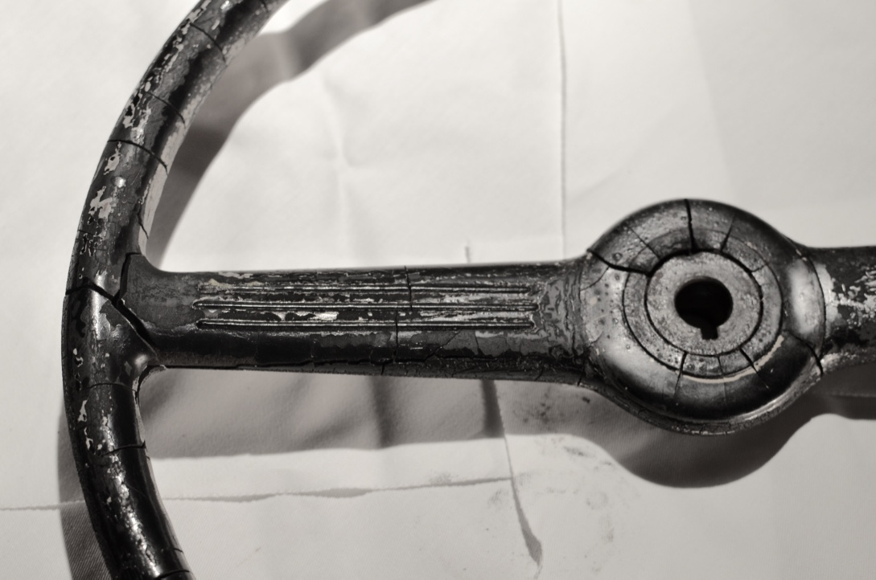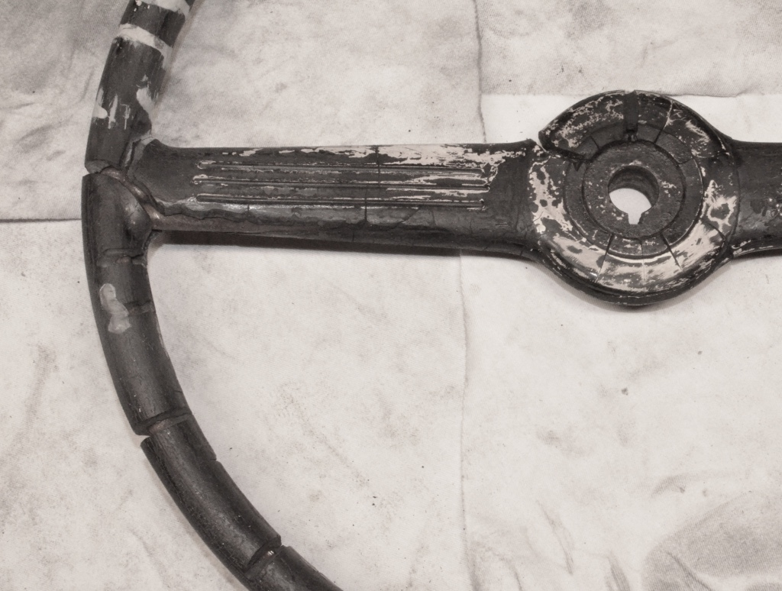

Up next was the task of repairing the wheel. There are many materials available for the job. JB Weld, PC-7, and POR-15 seem to be the most popular epoxy product for this application. I selected POR-15 because it is easy to mix, apply and sand. POR-15 is a two-part epoxy that looks like silly putty. To mix, you cut an equal amount of part A and B and squeeze into a ball. Roll the ball between your hands to form a long thin piece, double over and twist. Roll the material into a ball and repeat the process until the putty is one consistent color. Press the epoxy into each crack; ensuring it completely fills the crack. It is important to trim any excess epoxy as it reduces the amount of sanding required. The POR-15 hardens rock solid in 24 hours. I used the oscillating sander to sand the front of the wheel, the part that is smooth, and used the sanding bits in the rotary tool to sand the finger grips on the back of the wheel, and the corners where the center posts meet the wheel. This is a process that takes time and patience.

Part II of this article, which will cover painting the wheel, will appear in the May edition of the new

[After cracks are filled] [Roary tool and oscillating sander]